//Hello world flutter code

//https://www.javatpoint.com/flutter-first-application

//https://docs.flutter.dev/get-started/codelab

// Copyright 2018 The Flutter team. All rights reserved.

// Use of this source code is governed by a BSD-style license that can be

// found in the LICENSE file.

import 'package:flutter/material.dart'; //(In the first line we have imported the material //design library which will be used in this app.)

void main() {//This is the point where the code execution will start

runApp(const MyApp()); //This line is an entry point of the Flutter applications similar to //the main method in other programming languages. It calls the **runApp** function and //pass it an object of **MyApp *The primary purpose of this function is to attach the given //widget to the screen.***

}

class MyApp extends StatelessWidget { //This is basically the main widget tree of our //‘hello world’ app. the **StatelessWidget** does not maintain any state of the widget.

const MyApp({Key? key}) : super(key: key);/\***Curly brackets** of {Key key, this.title}: is the syntax for declaring **optional parameters** while defining function in Dart.

**The first colon** of MyHomepage(...) : super(key: key) is a separator that specifies the **initializer list** (super(key: key)) of constructor function MyHomepage(...)

**The second colon** within super(key: key) is the way how you **pass a parameter** to a **named function** (super() in this case).*/

@override

Widget build(BuildContext context) {//MyApp extends StatelessWidget that overrides its **build** The build method is used for creating a part of the UI of the application. In this block, the build method uses MaterialApp, a widget to create the root level UI of the application and contains three properties - title, theme, and home.

return MaterialApp(

title: 'Welcome to Flutter',

home: Scaffold( //The Scaffold widget contains the whole screen of the app.

appBar: AppBar(//We have used the *appBar* property which is taking the //*AppBar* widget as the object.

title: const Text('Welcome to Flutter'),

),

body: const Center(//*body,* which is again the property of the *MaterialApp*.

child: Text('Hello World'),

),

),

);

}

}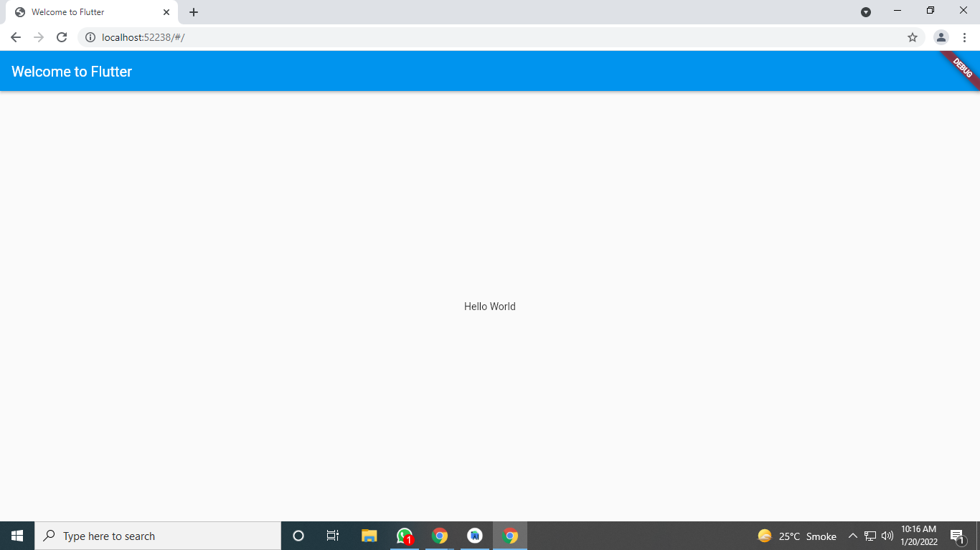

**//Main.dart file Flutter Animation Basic Example to increase font by pressing button**

import 'dart:math';

import 'package:flutter/material.dart';

void main() => runApp(const AnimatedContainerApp());

class AnimatedContainerApp extends StatefulWidget {

const AnimatedContainerApp({super.key});

@override

State<AnimatedContainerApp> createState() => _AnimatedContainerAppState();

}

class _AnimatedContainerAppState extends State<AnimatedContainerApp> {

// Define the various properties with default values. Update these properties

// when the user taps a FloatingActionButton.

double _width = 50;

double _height = 50;

Color _color = Colors.green;

BorderRadiusGeometry _borderRadius = BorderRadius.circular(8);

@override

Widget build(BuildContext context) {

return MaterialApp(

home: Scaffold(

appBar: AppBar(

title: const Text('AnimatedContainer Demo'),

),

body: Center(

child: AnimatedContainer(

// Use the properties stored in the State class.

width: _width,

height: _height,

decoration: BoxDecoration(

color: _color,

borderRadius: _borderRadius,

),

// Define how long the animation should take.

duration: const Duration(seconds: 1),

// Provide an optional curve to make the animation feel smoother.

curve: Curves.fastOutSlowIn,

),

),

floatingActionButton: FloatingActionButton(

// When the user taps the button

onPressed: () {

// Use setState to rebuild the widget with new values.

setState(() {

// Create a random number generator.

final random = Random();

// Generate a random width and height.

_width = random.nextInt(300).toDouble();

_height = random.nextInt(300).toDouble();

// Generate a random color.

_color = Color.fromRGBO(

random.nextInt(256),

random.nextInt(256),

random.nextInt(256),

1,

);

// Generate a random border radius.

_borderRadius =

BorderRadius.circular(random.nextInt(100).toDouble());

});

},

child: const Icon(Icons.play_arrow),

),

),

);

}

}

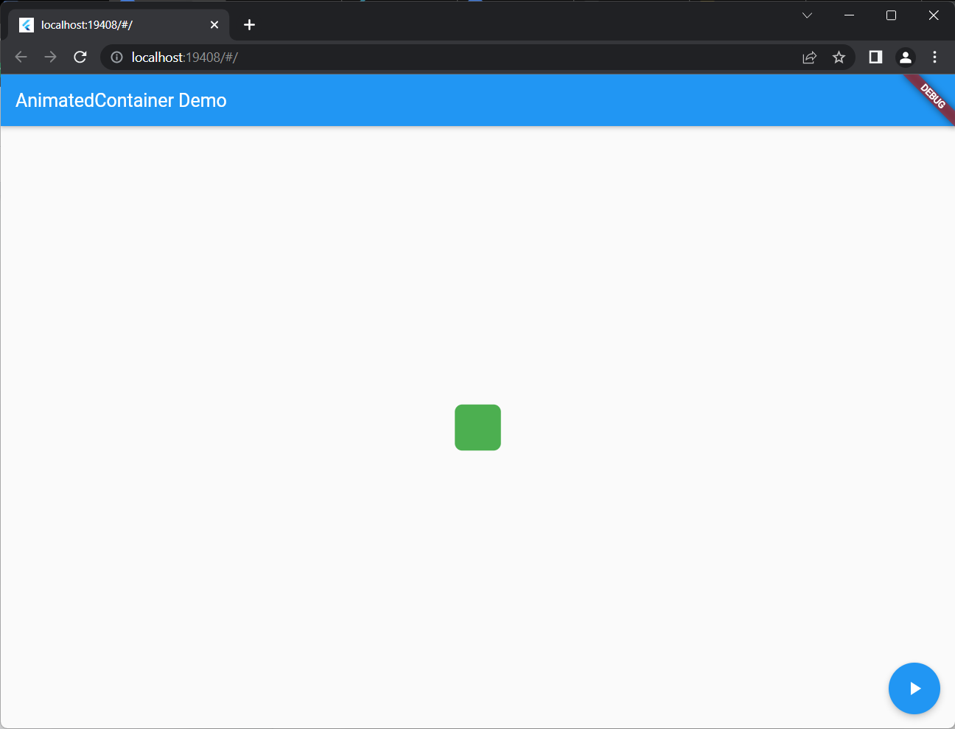

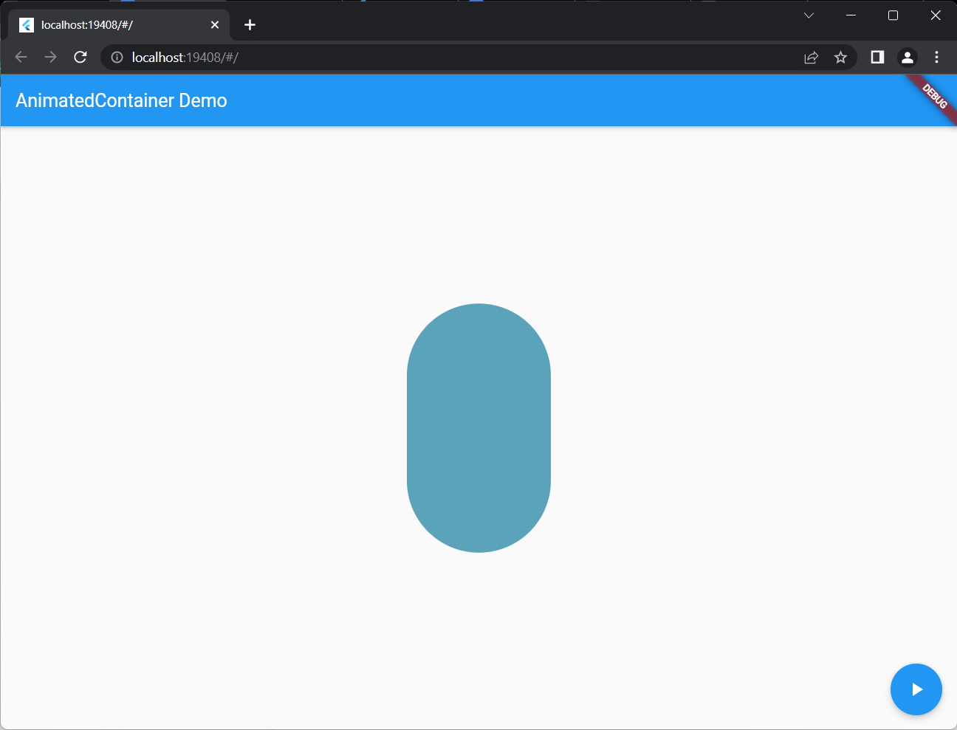

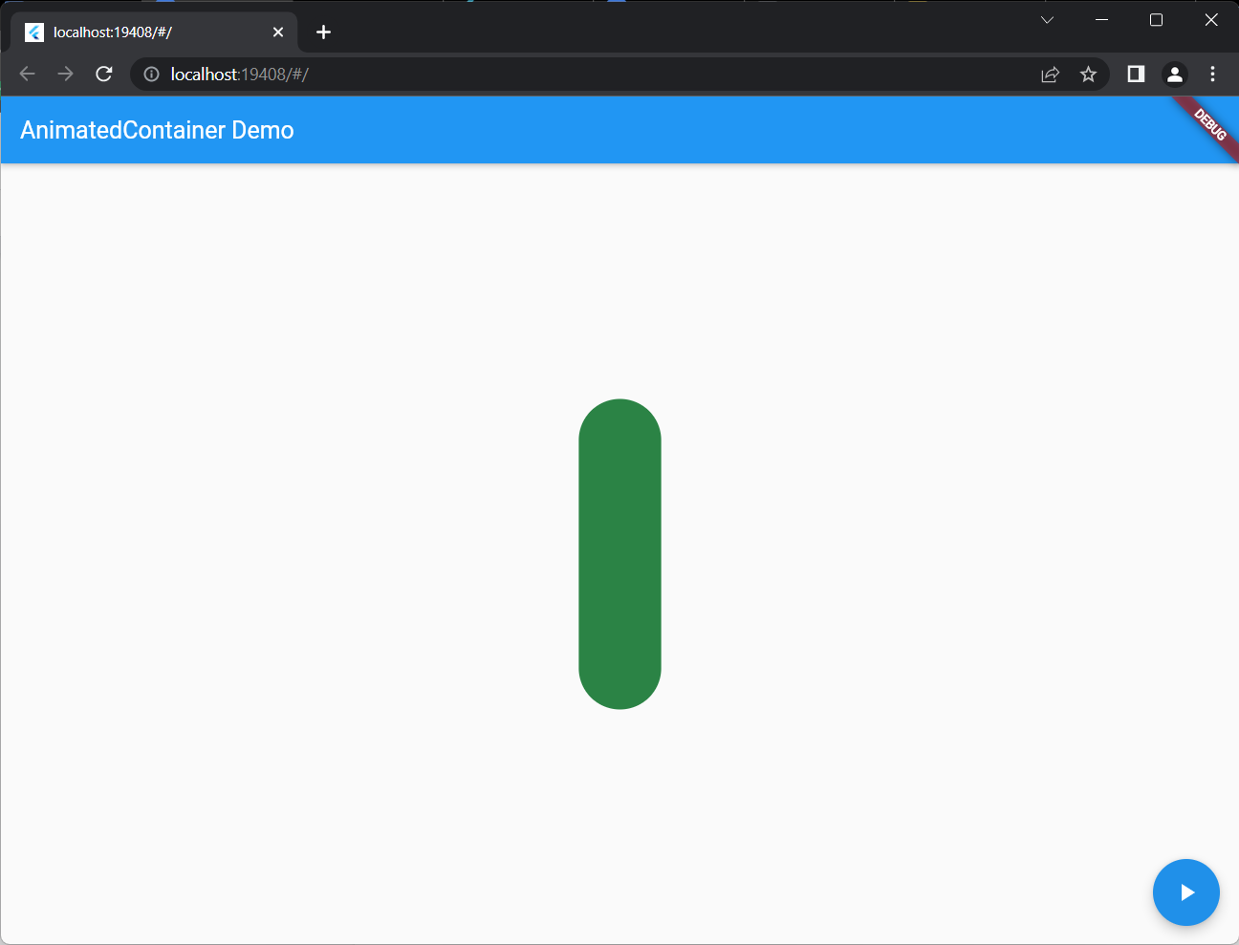

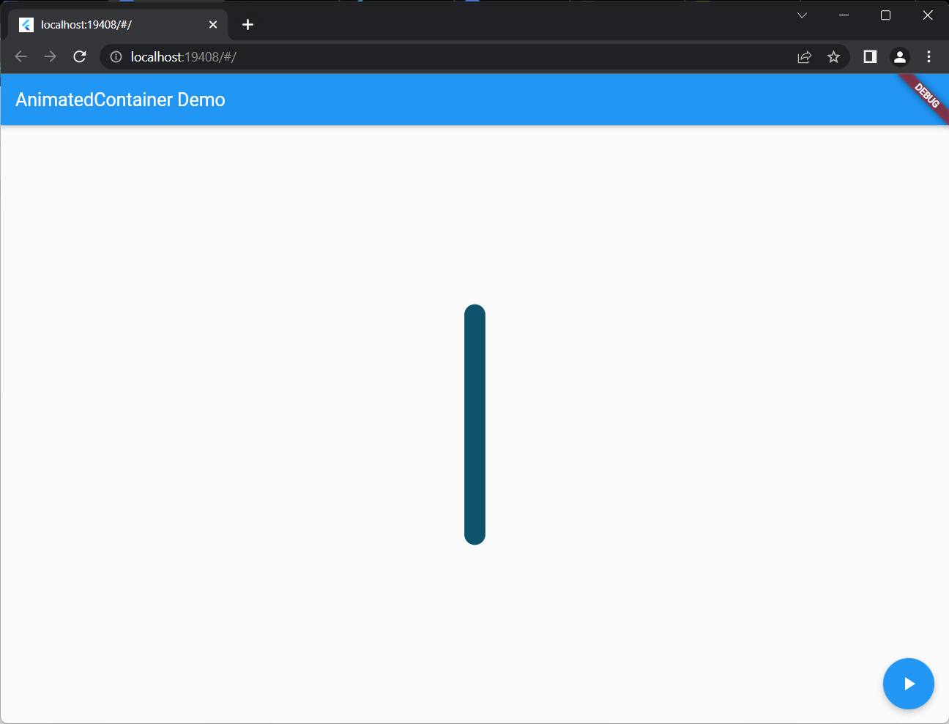

Example : display image

//main.dart file

import 'package:flutter/material.dart';

void main() {

runApp(const MyApp());

}

class MyApp extends StatelessWidget {

const MyApp({Key? key}) : super(key: key);

@override

Widget build(BuildContext context) {

return MaterialApp(

title: 'Welcome to Flutter',

home: Scaffold(

appBar: AppBar(

title: const Text('Welcome to Flutter'),

),

body: Center(

child: Image.asset('comp.jpg'),

),

),

);

}

}



//Comp.jpg image

//Create assets folder insert this image

//Make changes in pubspec.yaml file.include these lines

assets:

- assets/comp.jpg

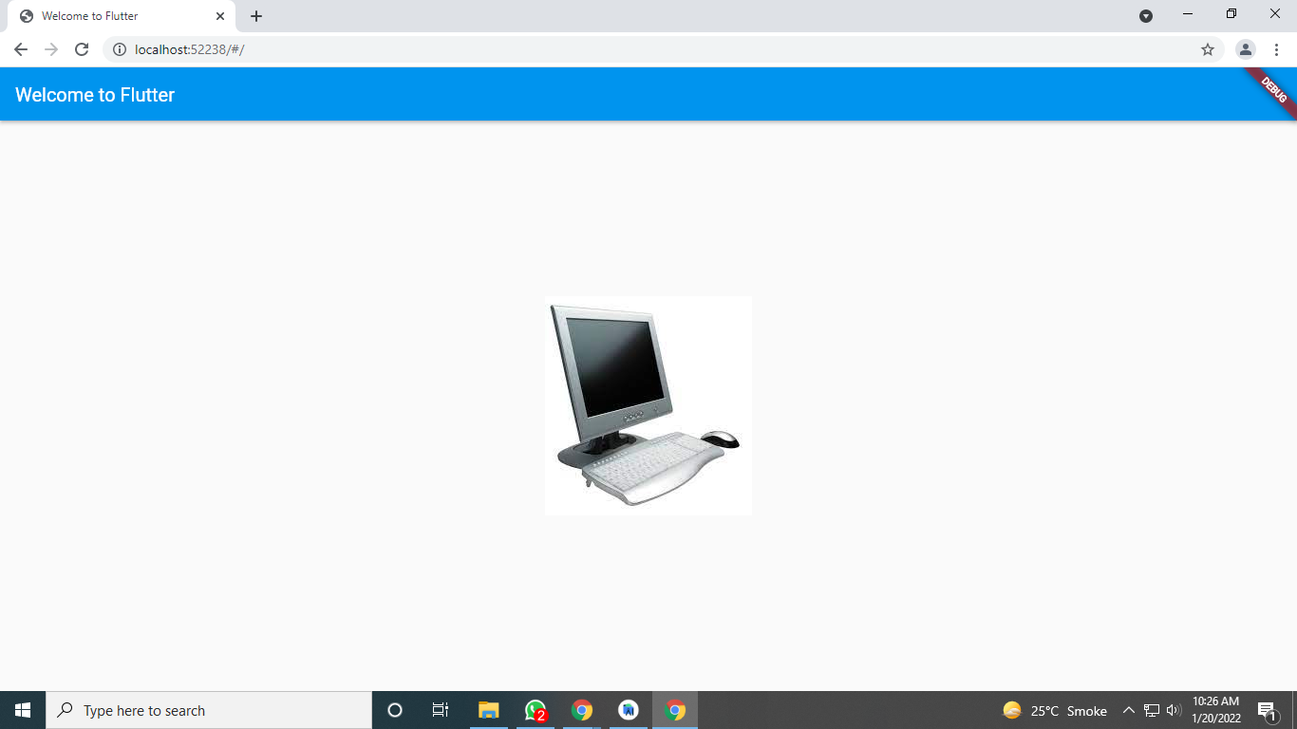

//Example column demo

| import 'package:flutter/material.dart';    void main() => runApp(const MyApp());    /// main application widget.  class MyApp extends StatelessWidget {  const MyApp({Key? key}) : super(key: key);    static const String _title = 'Flutter Tutorial';    @override  Widget build(BuildContext context) {  return const MaterialApp(  title: _title,  home: MyStatefulWidget(),  );  }  }    /// stateful widget that the main application instantiates  class MyStatefulWidget extends StatefulWidget {  const MyStatefulWidget({Key? key}) : super(key: key);    @override  State<MyStatefulWidget> createState() => _MyStatefulWidgetState();  }    /// private State class that goes with MyStatefulWidget  class _MyStatefulWidgetState extends State<MyStatefulWidget> {    @override  Widget build(BuildContext context) {  return Scaffold(  appBar: AppBar(  title: const Text('Column Widget Tutorial'),  ),  body: Center(  child: Column(  children: const <Widget>[  Text('Text 1', style: TextStyle(fontSize: 24.0),),  Text('Text 2', style: TextStyle(fontSize: 24.0),),  Icon(  Icons.beach_access,  color: Colors.pink,  size: 30.0,  ),  Icon(  Icons.audiotrack,  color: Colors.green,  size: 30.0,  ),  ],  )  ),  );  }  }    //Example Row  import 'package:flutter/material.dart';  void main() => runApp(const MyApp());  */// main application widget.*  class MyApp extends StatelessWidget {  const MyApp({Key? key}) : super(key: key);  static const String *_title* = 'Flutter Tutorial';  @override  Widget build(BuildContext context) {  return const MaterialApp(  title: *_title*,  home: MyStatefulWidget(),  );  }  }  */// stateful widget that the main application instantiates*  class MyStatefulWidget extends StatefulWidget {  const MyStatefulWidget({Key? key}) : super(key: key);  @override  State<MyStatefulWidget> createState() => _MyStatefulWidgetState();  }  */// private State class that goes with MyStatefulWidget*  class _MyStatefulWidgetState extends State<MyStatefulWidget> {  @override  Widget build(BuildContext context) {  return Scaffold(  appBar: AppBar(  title: const Text('Row Widget Tutorial'),  ),  body: Row(  children: const <Widget>[  Text('Text 1', style: TextStyle(fontSize: 24.0,), ),  Icon(  Icons.*beach_access*,  color: Colors.*pink*,  size: 90.0,  ),  Text('Text 2', style: TextStyle(fontSize: 20.0),),  Icon(  Icons.*audiotrack*,  color: Colors.*green*,  size: 90.0,  ),  ],  )  );  }  } |
| --- |

//Flutter example Stack widget

**import** 'package:flutter/material.dart';

**void** main() => runApp(MyApp());

/// This Widget is the main application widget.

**class** MyApp **extends** StatelessWidget {

@override

Widget build(BuildContext context) {

**return** MaterialApp(

home: MyStackWidget(),

);

}

}

**class** MyStackWidget **extends** StatelessWidget {

@override

Widget build(BuildContext context) {

**return** MaterialApp(

home: Scaffold(

appBar: AppBar(

title: Text("Flutter Stack Widget Example"),

),

body: Center(

child: Stack(

fit: StackFit.passthrough,

overflow: Overflow.visible,

children: <Widget>[

// Max Size Widget

Container(

height: 300,

width: 400,

color: Colors.green,

child: Center(

child: Text(

'Top Widget: Green',

style: TextStyle(color: Colors.white, fontSize: 20),

),

),

),

Positioned(

top: 30,

right: 20,

child: Container(

height: 100,

width: 150,

color: Colors.blue,

child: Center(

child: Text(

'Middle Widget',

style: TextStyle(color: Colors.white, fontSize: 20),

),

),

),

),

Positioned(

top: 30,

left: 20,

child: Container(

height: 100,

width: 150,

color: Colors.orange,

child: Center(

child: Text(

'Bottom Widget',

style: TextStyle(color: Colors.white, fontSize: 20),

),

),

)

),

],

),

)

),

);

}

}

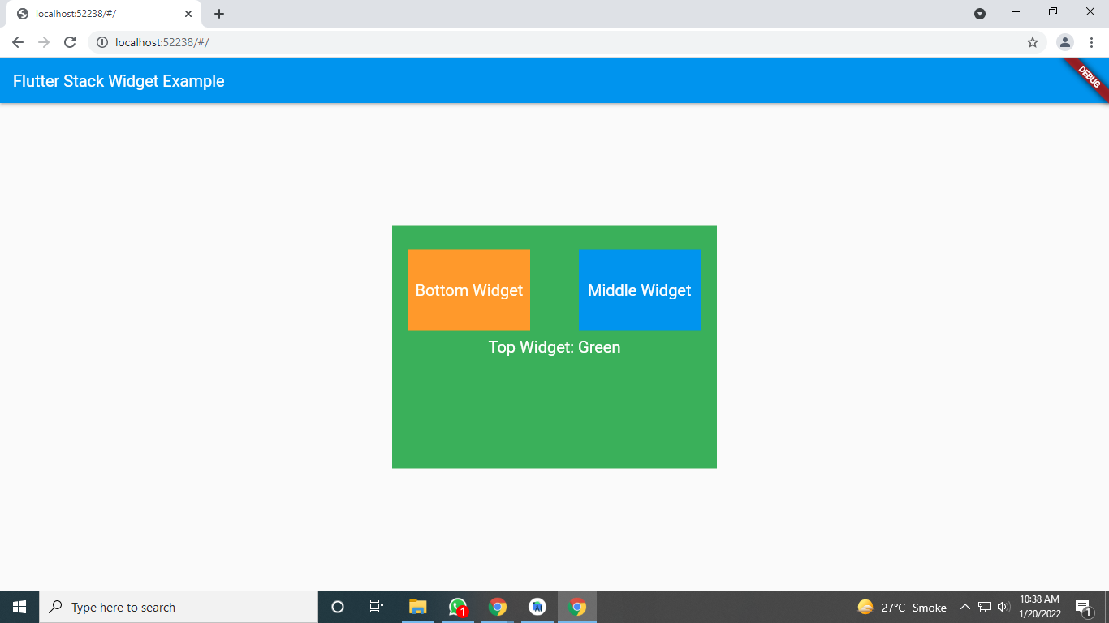

//flutter example list view

| import 'package:flutter/material.dart';    void main() => runApp(MyApp());    class MyApp extends StatelessWidget {  @override  Widget build(BuildContext context) {  return MaterialApp(  title: 'Flutter Demo',  theme: ThemeData(  primarySwatch: Colors.blue,  ),  home: Scaffold(  appBar: AppBar(  title: Text('TutorialKart - Flutter ListView'),  ),  body: ListView(  children: <Widget>[  Container(  height: 50,  color: Colors.lime[800],  child: const Center(child: Text('Apple')),  ),  Container(  height: 50,  color: Colors.lime[600],  child: const Center(child: Text('Banana')),  ),  Container(  height: 50,  color: Colors.lime[400],  child: const Center(child: Text('Mango')),  ),  Container(  height: 50,  color: Colors.lime[200],  child: const Center(child: Text('Orange')),  ),  ],  ),  ),  );  }  } |
| --- |

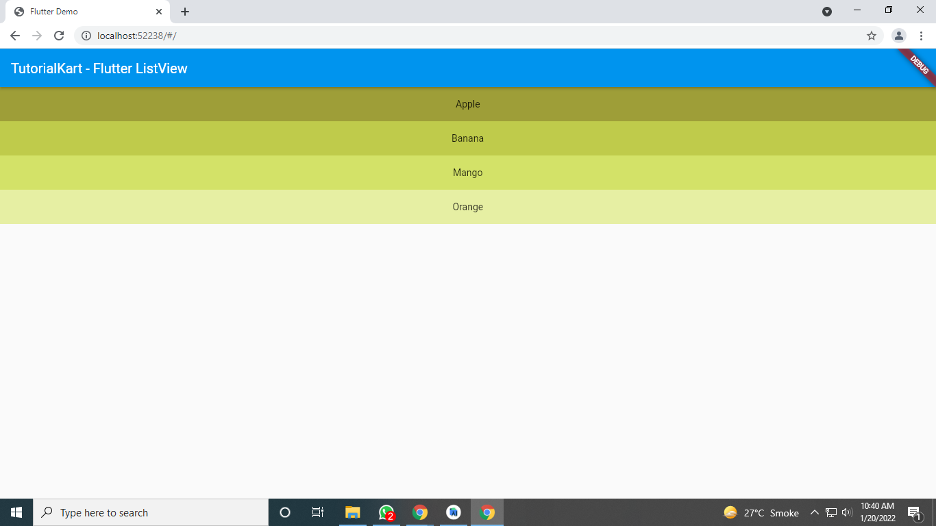

//flutter drawer example

//<https://docs.flutter.dev/cookbook/design/drawer>

import 'package:flutter/material.dart';

void main() => runApp(const MyApp());

class MyApp extends StatelessWidget {

const MyApp({Key? key}) : super(key: key);

static const appTitle = 'Drawer Demo';

@override

Widget build(BuildContext context) {

return const MaterialApp(

title: appTitle,

home: MyHomePage(title: appTitle),

);

}

}

class MyHomePage extends StatelessWidget {

const MyHomePage({Key? key, required this.title}) : super(key: key);

final String title;

@override

Widget build(BuildContext context) {

return Scaffold(

appBar: AppBar(title: Text(title)),

body: const Center(

child: Text('My Page!'),

),

drawer: Drawer(

// Add a ListView to the drawer. This ensures the user can scroll

// through the options in the drawer if there isn't enough vertical

// space to fit everything.

child: ListView(

// Important: Remove any padding from the ListView.

padding: EdgeInsets.zero,

children: [

const DrawerHeader(

decoration: BoxDecoration(

color: Colors.blue,

),

child: Text('Drawer Header'),

),

ListTile(

title: const Text('Item 1'),

onTap: () {

// Update the state of the app

// ...

// Then close the drawer

Navigator.pop(context);

},

),

ListTile(

title: const Text('Item 2'),

onTap: () {

// Update the state of the app

// ...

// Then close the drawer

Navigator.pop(context);

},

),

],

),

),

);

}

}